HANZIFY: A Sign Language Translation App
A PROJECT PROPOSAL REPORT
Submitted to
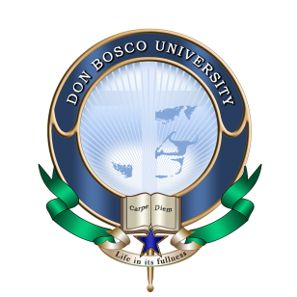
ASSAM DON BOSCO UNIVERSITY
by
SHIDHARTH LAISHRAM
DC2022BTE0131
KH DEEPAK KUMAR SINGHA
DC2022BTE0118
LAMJINGBA NINGOMBAM
DC2022BTE0095
in partial fulfilment for the award of the degree
of
BACHELOR OF TECHNOLOGY
IN
COMPUTER SCIENCE AND ENGINEERING

DEPARTMENT OF COMPUTER SCIENCE & ENGINEERING
SCHOOL OF TECHNOLOGY
ASSAM DON BOSCO UNIVERSITY
AZARA, GUWAHATI 781017
ASSAM, INDIA.
BATCH (2022- 2026)

TABLE OF CONTENTS

Sl. No | Contents | Page No.
1. | Introduction | 1-2
2. | Motivation | 3
3. | Problem Definition | 4-5
4. | Objectives | 6
5. | Existing System/Literature | 7-9
6. | Research Gaps/Novelty | 10
7. | Feasibility analysis  (H/W and S/W requirement and WBS/Gantt Chart) | 11-14
8. | Proposed Plan | 15-16
9. | Dataset And Ai-Models For ML | 17-19
10. | Design Diagram | 20-22
11. | Implementation | 23-31
12. | Conclusion | 32
13. | References | 33

1.INTRODUCTION
In today’s fast paced, interconnected world, effective communication remains at the heart of human interaction. However, the linguistic barrier between individuals who use spoken language and those who rely on sign language for communication often limits understanding. Recognizing this critical challenge, we present Hanzify – a cutting-edge sign language translation app designed to bridge this communication gap and foster an inclusive society where everyone’s voice is heard, irrespective of their mode of expression.
This project focuses on creating a sophisticated, versatile application that not only simplifies the communication between individuals but also enhances the overall experience and bring upon inclusiveness among people.
Key Features of Hanzify:
- Real-Time Translation: Translates sign language into spoken or written text and vice versa instantly, enabling seamless communication.
- Multi-Language Support: Supports multiple sign languages, including ASL (American Sign Language), BSL (British Sign Language), and more, catering to a global audience.
- Advanced AI and ML Technology: Utilizes cutting-edge gesture recognition, computer vision, and natural language processing to ensure accurate and contextually relevant translations.
- User-Friendly Interface: Designed for intuitive navigation, making it accessible for users of all technical skill levels.
- Multi-Platform Compatibility: Works across various platforms, including smartphones and tablets, ensuring flexibility and convenience for users.
- Versatile Applications: Suitable for diverse environments such as schools, workplaces, healthcare, facilities and public services.
- High Translation Accuracy: Delivers precise translations with contextual understanding, setting it apart from other tools.
- Offline Mode: Provides the ability to function in offline mode for areas with limited or no internet connectivity, ensuring continuous usability.
- Continuous Learning and Updates: The app evolves with updates, enhancing recognition accuracy and incorporation user feedback.
By providing tools that promote accessible education, inclusivity, and equitable opportunities, the app contributes to building a society where no one is left behind. It enables individuals with hearing impairments to access information, participate in conversations, and engage in societal activities, thereby fostering a more sustainable and inclusive future.

With Hanzify, harnessing the power of machine learning and artificial intelligence technologies, communication has no bounds. It is not just a tool but a statement of commitment to innovation, and the belief that technology can make the world a better place for all.

2.MOTIVATION
The inspiration for Hanzify stems from the widespread challenges faced by millions of people who rely on sign language for communication. These individuals often encounter significant barriers in education, professional environments, healthcare, and social interactions, as the majority of society remains untrained in sign language. This lack of inclusivity not only limits their opportunities but also perpetuates a sense of isolation and inequality. Observing this reality, we felt compelled to create a solution that bridges this gap and promotes meaningful connection between sign language users and the wider community.
The development of Hanzify is fuelled by a profound belief in the power of technology to break barriers and empower individuals. The app is not just about translating words, it’s about enabling deeper connections and fostering understanding. By leveraging advancements in machine learning, gesture recognition, and natural language processing, we aim to create a tool that is highly accurate, adaptable, and capable of addressing the unique sophistication of different sign languages across the globe.
Moreover, the motivation behind Hanzify goes beyond communication. It’s about creating an effect of change—encouraging organizations, institutions, and communities to embrace inclusivity as a core value. With Hanzify, schools can provide equal learning opportunities to students with hearing impairments, workplaces can ensure better collaboration, and public services can cater to a broader audience without discrimination. This app is a step toward building a society where accessibility is a norm, not an afterthought.
At last, Hanzify is driven by a vision of equity and inclusion. It aspires to create a world where communication is not defined by physical abilities but by shared understanding and empathy. Through Hanzify, we seek to demonstrate that technology is not just a tool but a catalyst for societal progress, breaking down barriers and ensuring that every individual has the opportunity to be heard and understood.

3.PROBLEM DEFINITION
The communication gap between sign language users and non-sign language users is a persistent challenge that has far-reaching consequences in various spheres of life. Despite advancements in technology and awareness, this gap continues to create significant barriers, hindering equal opportunities and social integration. The lack of effective tools to facilitate real-time, contextually accurate translation between sign language and spoken languages exacerbates these issues.
Key problems include:
- Lack of Universal Access to Sign Language Translation: While some tools exist, they are often region-specific, catering to a single sign language, such as ASL (American Sign Language) or BSL (British Sign Language). This limitation excludes users who rely on other sign languages, leaving a large portion of the global population underserved.
- Inadequate Real-Time Communication Solutions: Effective communication often requires real-time interaction. Existing technologies struggle to provide instantaneous, context-aware translations that mimic natural human conversation. This shortfall makes communication cumbersome and less effective, particularly in dynamic environments like classrooms, hospitals, or customer service interactions.
- High Costs and Limited Availability: Many available solutions are prohibitively expensive, making them inaccessible to individuals and organizations with limited financial resources. Moreover, these tools often require specialized hardware or training, further limiting their adoption.
- Exclusion in Critical Environments: The absence of reliable translation tools means that individuals who rely on sign language face exclusion in crucial settings such as education, healthcare, and employment. For example, students may struggle to access quality education due to the lack of interpreters, while patients may face difficulties conveying their needs in medical emergencies.
- Lack of Awareness and Cultural Understanding: Beyond technological barriers, a significant problem lies in societal attitudes and awareness. Many people lack basic knowledge about sign language and its importance, perpetuating misunderstandings and stigmas surrounding deaf communities.
Hanzify addresses these challenges by:
- Providing a comprehensive platform that supports multiple sign languages, making it accessible to a global audience.
- Leveraging cutting-edge machine learning and artificial intelligence to ensure real-time, contextually accurate translations.
- Offering an affordable, user-friendly solution that works across multiple devices, eliminating the need for specialized hardware.
- Bridging gaps in critical environments, empowering individuals to participate fully in education, employment, and healthcare.
- Promoting awareness and inclusivity by fostering better understanding and interaction between sign language users and non-users.
By tackling these problems head-on, Hanzify is not just a technological solution but a step toward a more inclusive and equitable society where communication is a right, not a privilege.

4.OBJECTIVES
The objectives of Hanzify app mini project is:
- To develop a robust machine learning model for real-time sign language detection.
  - This includes preprocessing sign language gestures, extracting features, and training machine learning or deep learning algorithms to accurately classify gestures into corresponding meanings.
  - The study will involve exploring image processing, pose estimation, and gesture recognition techniques to improve detection accuracy under diverse conditions (e.g., lighting, camera angles, and occlusions).
- To create an application integrating the sign language detection model.
- The application will transform detected sign language gestures into text and speech outputs, providing accessibility for both hearing and non-hearing users.
- The system will include features like sign language translation, customizable language settings, and real-time feedback for enhancing user experience.

SDG Goals:
Beyond addressing communication barriers, Hanzify aligns with several United Nations Sustainable Development Goals (SDGs):
- SDG 4 (Quality Education): By bringing upon an inclusive education among specially-abled users.
- SDG 10 (Reduced Inequalities): By removing the gap between non-impaired and impaired users.
- SDG 11 (Sustainable Cities and Communities): By being scalable bringing the society into one with no differences.

5.EXISTING SYSTEMS/LITERATURE
5.1 Existing Systems:
Several systems and tools exist in the domain of sign language recognition and translation, each having their own strength and limitations. Some prominent existing systems are given below:
- Google Translate (ASL Keyboard Integration)
  - Google Translate provides limited support for sign languages, including features like an ASL keyboard for text input.
  - Limitation: It lacks real-time video-based recognition and comprehensive sign language-to-speech capabilities.
- ASL Translator by AppMySite
  - A mobile app that translates text into sign language animations (signs).
  - Limitation: Primarily one-directional and lacks real-time communication features.
- Microsoft Azure Cognitive Services
  - Includes features for gesture and speech recognition but does not directly provide end-to-end sign language translation.
  - Limitation: Requires extensive customization and technical expertise for implementation.
  - Literature Review:
The following literature outlines the current research, methodologies and gaps in the field of sing language translation:
- “SIGN LANGUAGE TRANSLATOR - A NOVEL APPROACH FOR REAL-TIME SIGN LANGUAGE TRANSLATOR USING PYTHON AND MACHINE LEARNING” by Prof. Sujata Dake
  - Summary: The paper introduces a real-time sign language translator using machine learning and computer vision to bridge communication gaps for the hearing impaired. The system employs advanced neural networks to recognize gestures and translate them into written language for better inclusivity.
  - Findings: The model demonstrates high accuracy in recognizing diverse sign language gestures and effectively translates them in real time, enhancing accessibility and fostering communication.
  - Research Gap: The study identifies a need for broader dataset inclusivity, improved temporal gesture recognition, and better integration across varying regional sign languages.

- “ADVANCEMENTS IN SIGN LANGUAGE RECOGNITION: A COMPREHENSIVE REVIEW AND FUTURE PROSPECTS” by Bashaer A. AI Abdullah

  - Summary: The paper provides a comprehensive review of advancements in sign language recognition technologies, emphasizing machine learning and deep learning models for gesture and context understanding.
  - Findings: The study highlights the progress in accuracy, multi-language recognition, and adaptability across diverse environments, demonstrating potential for real-world applications.
  - Research Gap: The gaps include limited datasets for training diverse sign languages, lack of contextual interpretation, and challenges in real-time integration for dynamic and complex environments.

- “HAND GESTURE RECOGNITION IN INDIAN SIGN LANGUAGE USING DEEP LEARNING” by Harsh Kumar Vashisth, Tuhin Tarafdar
  - Summary: The study explores hand gestures recognition for Indian Sign Language using deep learning, emphasizing the importance of accurate, real-time translation to improve communication for the deaf and mute communities.
  - Findings: High Accuracy was achieved using CNNs. A dataset specific to Indian Sign Language gestures was developed. The proposed models were performed well compared to traditional methods.
  - Research Gap: Limited focus on dynamic gestures and real-world lighting conditions. Lack of scalability for diverse sign language systems.

SUMMARY OF THE EXISTING SYSTEMS:
Sl. No. | System name | Cons
1. | Google Translate(ASL Keyboard) | - Limited support for sign languages, including features like an ASL keyboard for text input.
2. | ASL Translator | - Primarily one-direction and lacks real-time features.
3. | Microsoft Azure Cognitive Services | - Requires extensive customization and technical expertise for implementation.
FIGURE 1: TABLE OF EXISTING SYSTEMS
6.RESEARCH GAPS/NOVELTY
- Limited Real-Time and Accurate Translation Systems: Existing tools often lack the capability to provide real-time and contextually accurate translations. Hanzify introduces an advanced system powered by machine learning and gesture recognition that ensures instantaneous and precise translations.
- Global Inclusivity Across Multiple Sign Languages: While many existing solutions cater to a single sign language, Hanzify supports multiple sign languages such as ASL, BSL, and others, breaking regional barriers and ensuring global accessibility.
- Affordability Without Specialized Hardware: Current technologies often rely on expensive hardware like dedicated cameras or sensors. Hanzify is designed to function on standard devices such as smartphones and tablets, making it accessible to a broader audience.
- Holistic Approach to Accessibility: Combining gesture recognition with speech-to-text and text-to-speech capabilities, Hanzify provides a comprehensive solution for individuals with varying communication needs, promoting inclusivity at all levels.
- Awareness and Inclusivity Initiatives: Beyond being a translation tool, Hanzify aims to educate users about sign language and foster greater societal awareness, addressing cultural and educational gaps.
Novelty:
The novelty of Hanzify lies in its ability to address limitations and research gaps in existing sign language translation systems, making it distinct in the following ways:
1. Comprehensive Multi-Sign language Support: Unlike current systems that focus on a single sign language, Hanzify supports multiple languages (e.g., ASL, BSL, ISL) to cater to a global audience.
2. Real-Time Translation with Contextual Accuracy: Leveraging advanced AI, gesture recognition, and natural language processing, it ensures instant, precise, and contextually aware translations.
3. Universal Accessibility and Inclusivity: This app will operate on everyday devices, making it accessible to diverse socio-economic groups, and promotes social integration through educational components, awareness tools, and versatility across various environments.

By addressing issues like single-language focus, high costs, and limited contextual understanding, Hanzify stands out as a novel, transformative solution in the field of sign language recognition.
7. FEASIBILITY ANALYSIS
7.1 HARDWARE REQUIREMENTS
  - For Development:

    - Processor: Intel i7 9th Gen or higher, AMD Ryzen 5 or higher.
    - RAM: 8 GB (minimum).
    - Storage: 512 GB SSD (recommended).
    - Graphics: Dedicated GPU for training machine learning models.
    - Display: 1920 x 1080 resolution.
    - Camera: Webcam for gesture and sign detection testing.

  - For End Users:

    - Mobile Device: Android (7.0 or above).
    - Processor: Dedicated processor.
    - RAM: 2 GB (minimum).
    - Camera: Built-in camera for sign language detection.
    - Storage: 100 MB of free space for the app.

7.2 SOFTWARE REQUIREMENTS
- For Development:

    - Operating System: Windows 10/11.
    - Development Tools:
      - IDE (Integrated Development Environment): VS Code, Android Studio & Google Collab for training model.
      - OpenCV for computer vision processing.
      - TensorFlow or PyTorch for AI model development.
    - Programming Languages: Dart (for app development) & Python (for AI & ML).
    - Framework & Libraries: Flutter.
    - Database: Firebase.
    - Version Control: Git & GitHub.
    - APIs & Libraries:
      - TensorFlow.js for deploying AI models in mobile apps.
      - MediaPipe for gesture detection.
      - Natural Language Toolkit (NLTK) for NLP tasks.

- For End-Users:

    - Platform Compatibility: Android or iOS.
    - Permissions: Storage, camera, microphone.
    - Internet access: For real-time language updates (if required).

7.3 Work Breakdown Structure (WBS)
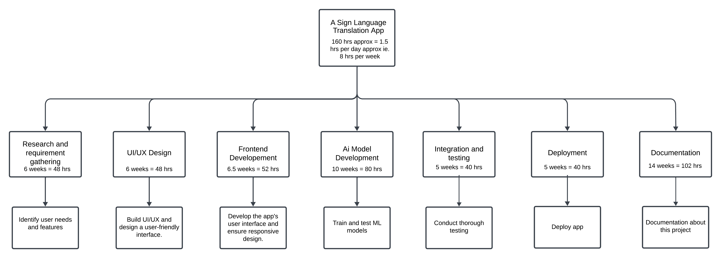
FIGURE 2: WORK BREAKDOWN STRUCTURE
The Work Breakdown Structure (WBS) for the Hanzify App provides a clear representation of all the essential phases involved in the development of the project, with corresponding working hours allocated to each phase. This structured approach helps to break down the project into manageable tasks and provides a comprehensive roadmap to ensure timely completion.
7.3.1 Calculation of total working hours:
1. Number of weeks in 5 months (January to May) = 20 Weeks
2. Number of working hours per week = 7-8 hours/week (let’s take 8)
3. Total working hours available = 8 hours/week x 20 weeks = 140 hours
4. No. Of working hour per day = 1 - 1.5 hours/day

7.4 GANTT CHART
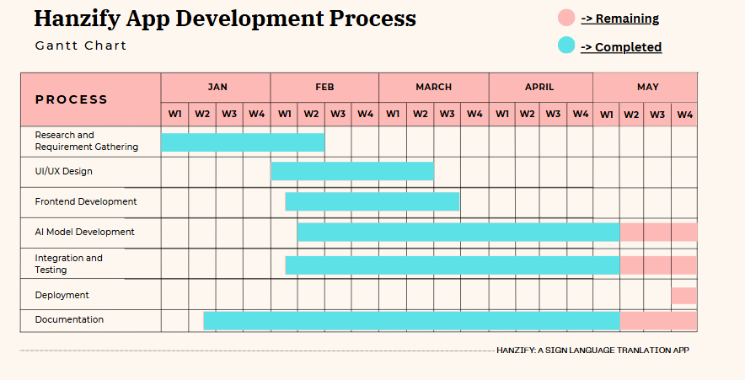
FIGURE 3: GANTT CHART
The diagram above illustrates the Gantt Chart for the Hanzify App Development Process, which represents the schedule and timeline for completing the various phases of the project. This chart serves as a visual tool for tracking progress, identifying dependencies, and ensuring that each task is completed within the allocated time frame.

8.PROPOSED PLAN
Phase 1: Research and Requirement Analysis (January)
        - Research Existing Solutions
  - Study current sign language translation tools
  - Identify their limitations and areas for improvement.
        - Define requirements:
  - Gather user requirements.
  - Finalize the list of supported sign languages (e.g., ASL, BSL etc.).
        - Finalize features:
  - Define key functionalities such as real-time translation, multi-language support, and contextual understanding.
Phase 2: Design & Planning (February)
- UI/UX Design:
  - Create wireframes of the app.
  - Ensuring the design is intuitive and accessible for all user abilities.
- Project Timeline:
  - Define milestones and allocate tasks using a Gantt Chart or WBS.
- System Architecture Design:
- Plan the app’s architecture, including front-end, back-end, and AI model components.
Phase 3: Development (February-April)
- AI/ML Model Development:
  - Build and train machine learning models for gesture recognition, natural language processing, and contextual analysis.
  - Ensure models are accurate and capable of handling diverse sign languages.
- Database Setup:
  - Design a database to store language data, user preferences, and translations.
- Core Application Development:
  - Develop front-end and back-end components.
  - Implement AI/ML models into the app.
  - Ensure compatibility with Android and iOS platforms.
Phase 4: Integration and Testing (April-May)
- Integration:
  - Combine AI/ML components, the database, and the app interface.
  - Ensure seamless interaction between modules.
- Testing:
  - Perform unit testing, integration testing, and user acceptance testing (UAT).
  - Address bugs and optimize performance for real-time functionality.
Phase 5: Deployment (May)
- Deployment:
  - Launch the app on app store (Google Play Store).
  - Ensure proper hosting and back-end support for real-time translation services.
- Feedback:
  - Gather user feedback through reviews.
  - Identify areas for improvement and plan future updates.
9.DATASET AND AI-MODELS FOR ML
9.1 Dataset of ASL(American sign Language)
This is the sample of the dataset for American Sign Language.
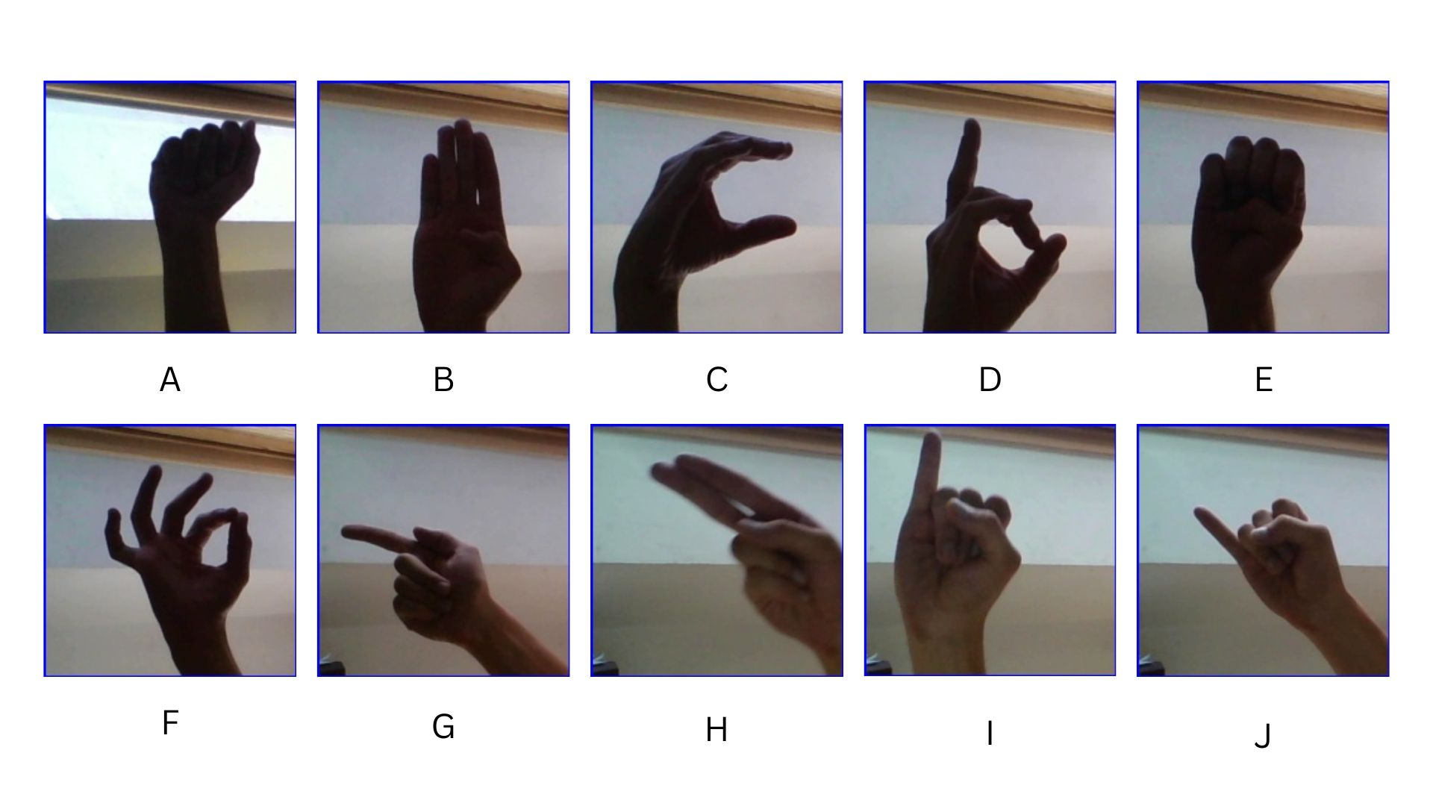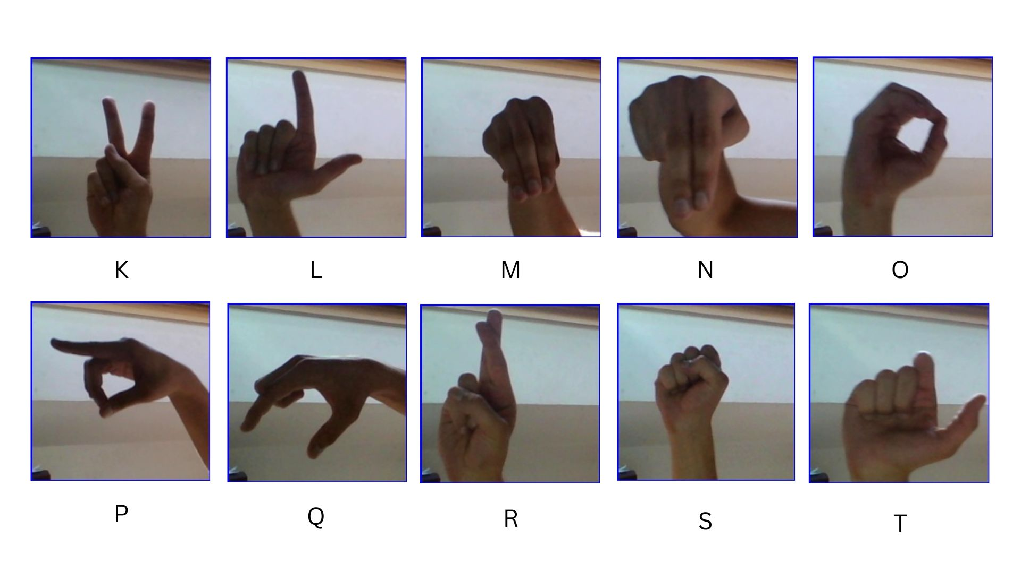
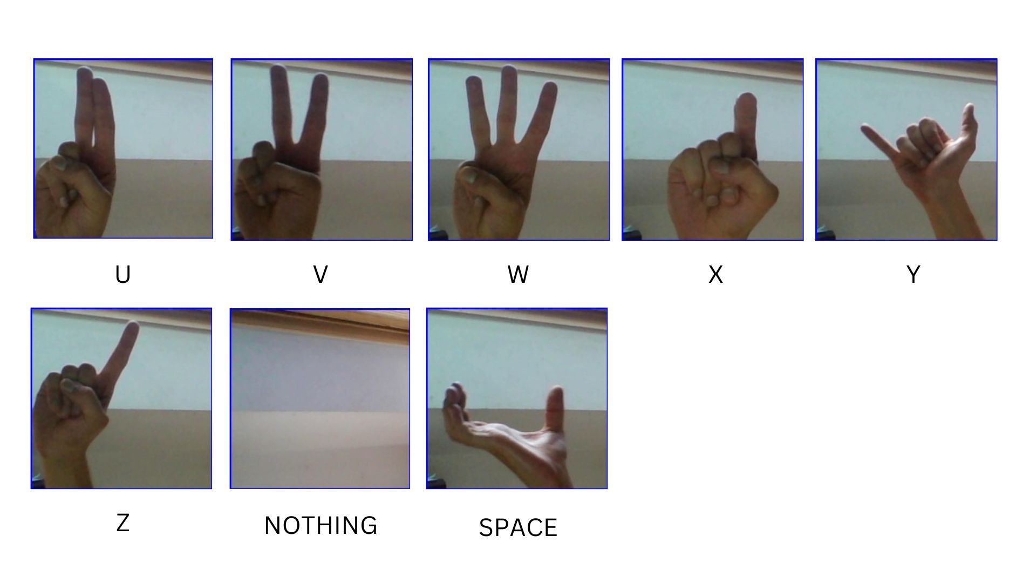FIGURE 4: ASL dataset

9.1 AI Model for Sign Language Detection
Real-time translation of sign language into text has challenges, especially on low to mid spec devices. This project aims to develop a sign language detection system using MobileNetV2, an efficient deep-learning model optimized for mobile applications.
MobileNetV2 is a lightweight convolutional neural network (CNN) that provides high accuracy with minimal computational resources. The key reasons for choosing MobileNetV2 include:
- Efficiency: Optimized for mobile and edge devices with low latency.
- Small Model Size: Uses depthwise separable convolutions, reducing the number of parameters.
- Fast Inference: Provides real-time performance on mobile devices.
- High Accuracy: Maintains a balance between efficiency and accuracy, making it suitable for sign language recognition.
Challenges & Solution
Challenge | Solution
High computational requirements | Use MobileNetV2, which is lightweight and optimized for mobile
Real-time processing delay | Apply quantization and use TensorFlow Lite for faster inference
Limited dataset availability | Augment existing datasets with variations in lighting, hand position, and background
FIGURE 5: Challenges and solution
10.DESIGN DIAGRAM
10.1 Use Case Diagram
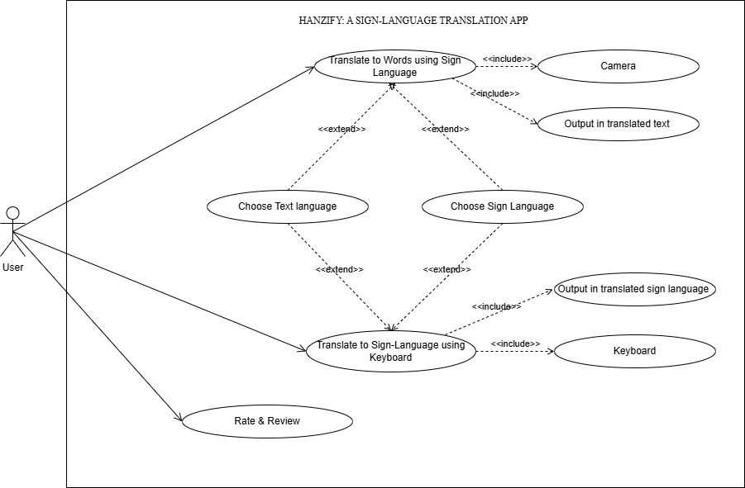

FIGURE 6: Use Case Diagram
10.2 Activity Diagram
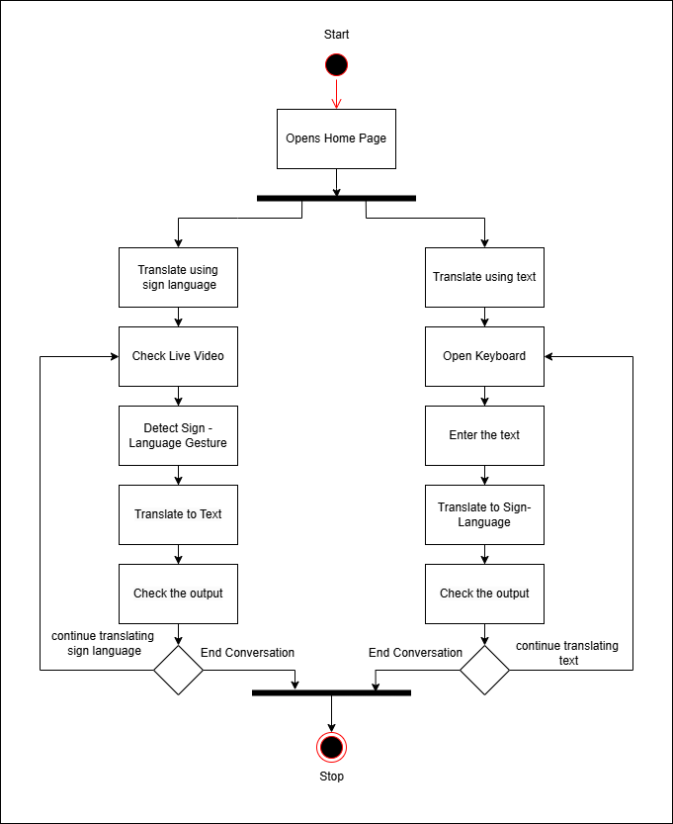

FIGURE 7: Activity Diagram
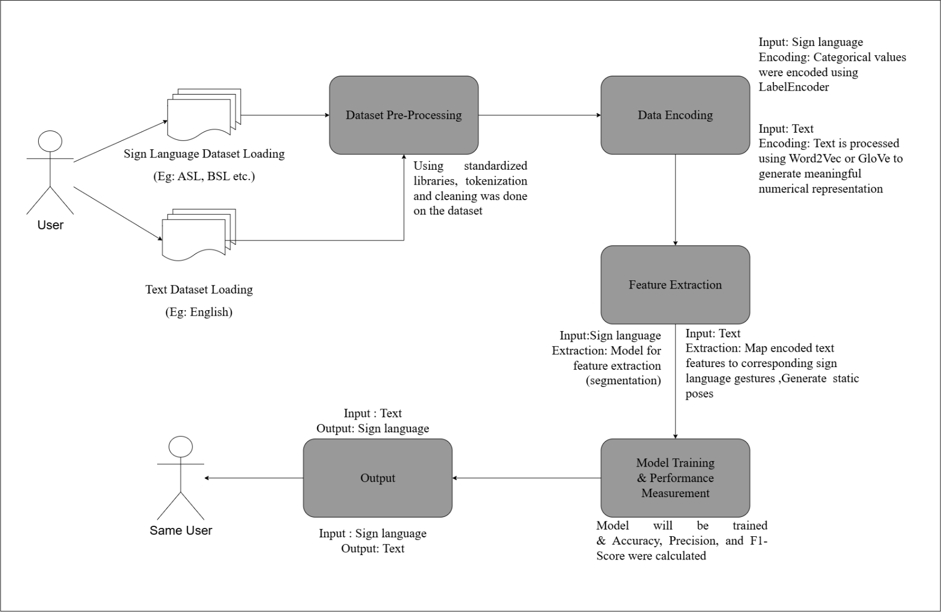
10.3 Block Diagram

FIGURE 8: Block Diagram

11.IMPLEMENTATION
11.1 UI/UX Design
Created mockups for:
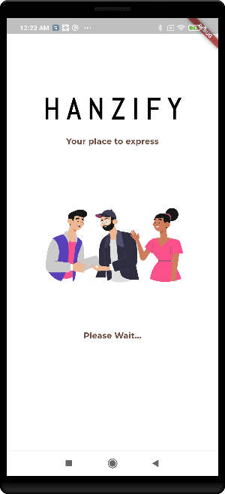
- Loading Page:

FIGURE 9: LOADING PAGE
          - This is the starting page when the app opens.
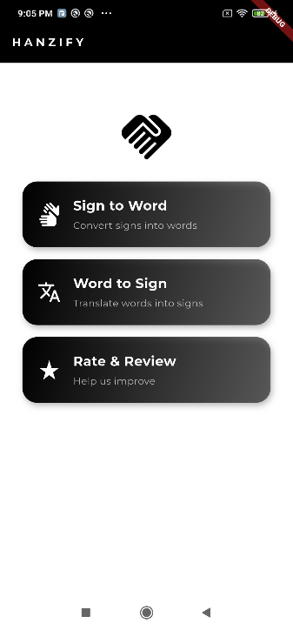
- Home page:

FIGURE 10: HOME PAGE
  - This is the home page.
  - The user will be able to access the features – Sign to Word, Word to Sign and Rate & Review.

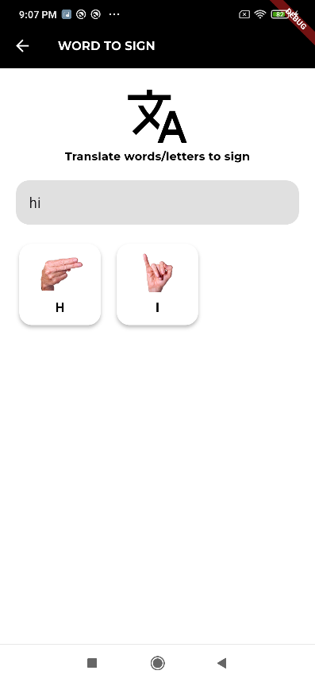
- Word To Sign page:

FIGURE 11: WORD TO SIGN PAGE
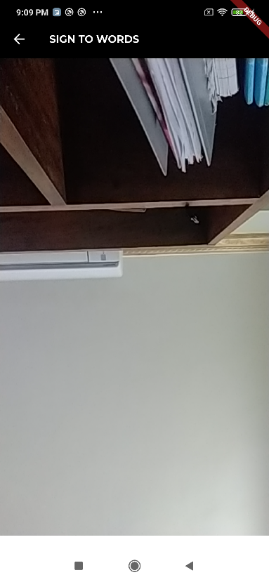
- Sign To Word page:

FIGURE 12: SIGN TO WORD PAGE
- Rate & Review page:
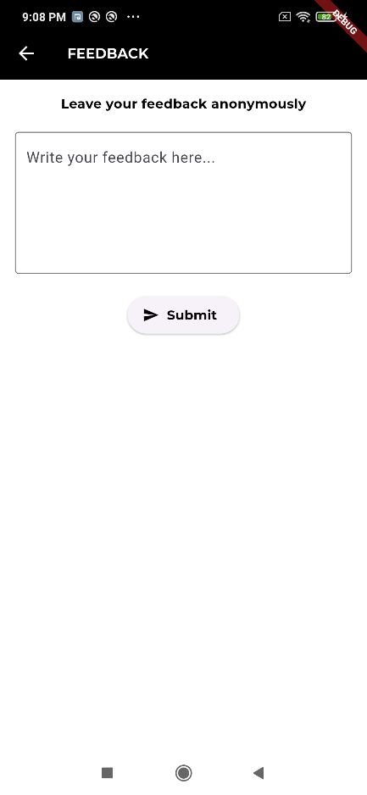

FIGURE 13: RATE & REVIEW PAGE

11.2 Code Snippet
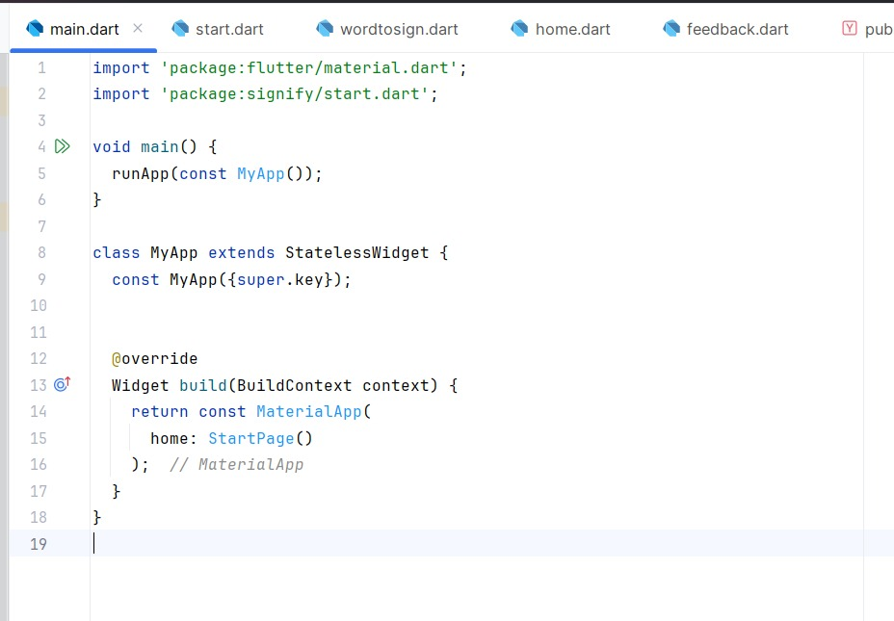
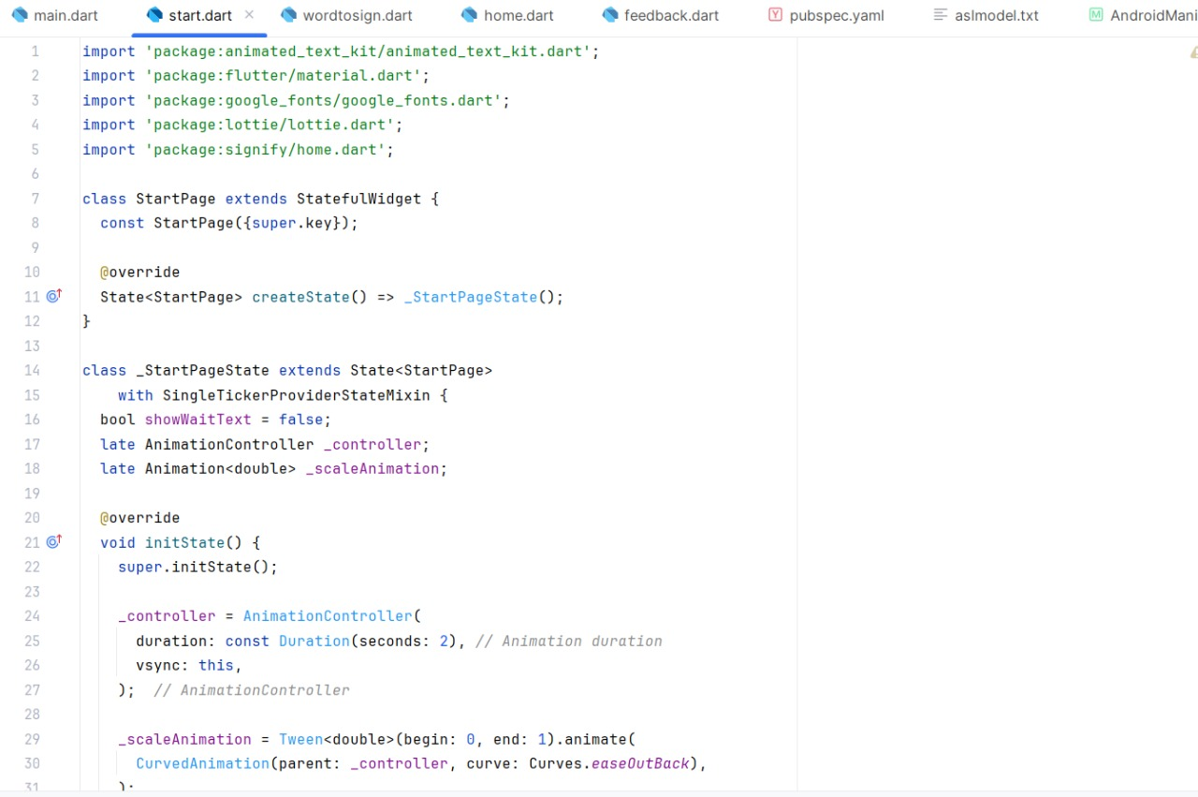

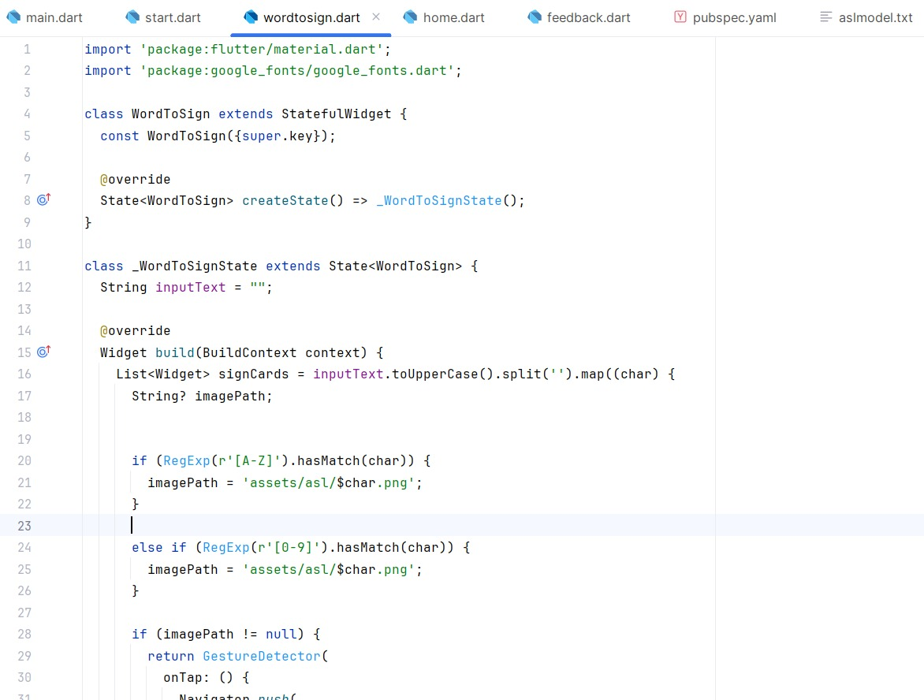
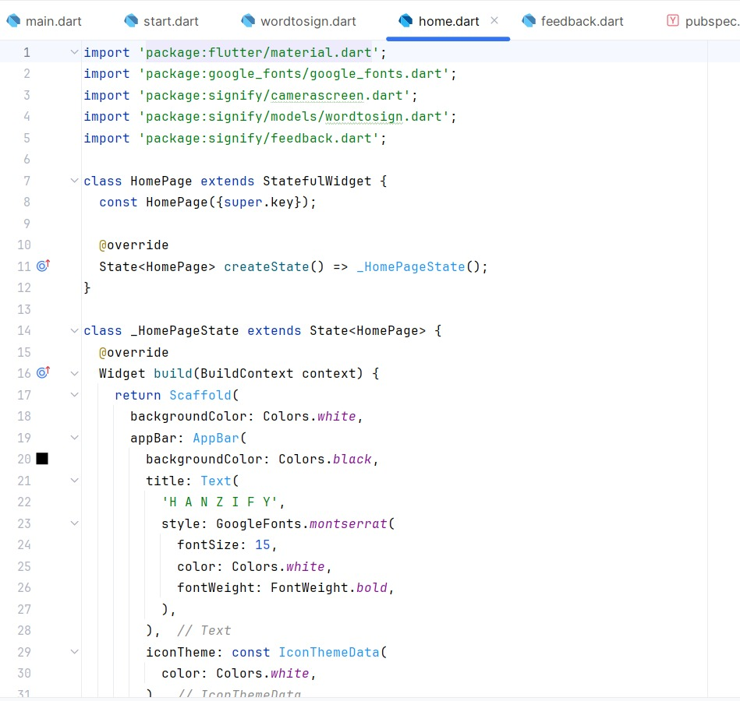
FIG 14: CODE SNIPPET (APP DEVELOPMENT)
11.3 MACHINE LEARNING MODEL:

We have chosen two models – Sequential Model and MobilenetV2 Model. We used and train the models using the ASL (American Sign Language) Dataset & Digits Dataset(0-9) from Kaggle.

Following is the outcomes or results for ASL Dataset, we have achieved after training the model:

11.3.1: SEQUENTIAL MODEL:
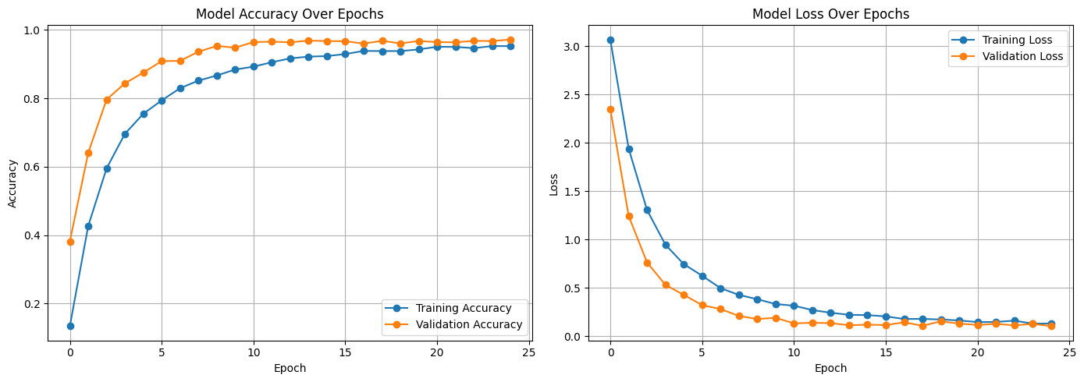
FIGURE 15: MODEL ACCURACY & MODEL LOSS (25 EPOCHS)

11.3.2: MOBILENETV2 MODEL:
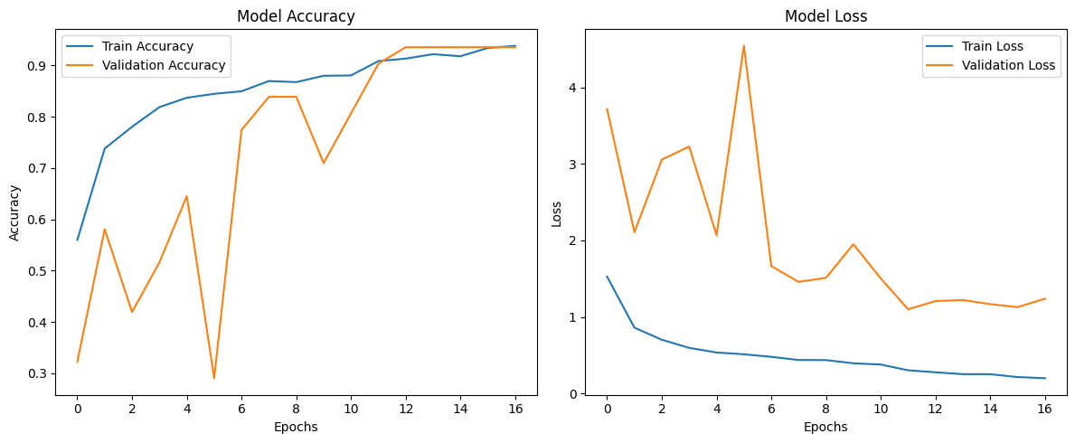
FIGURE 16: MODEL ACCURACY & MODEL LOSS (16 EPOCHS)

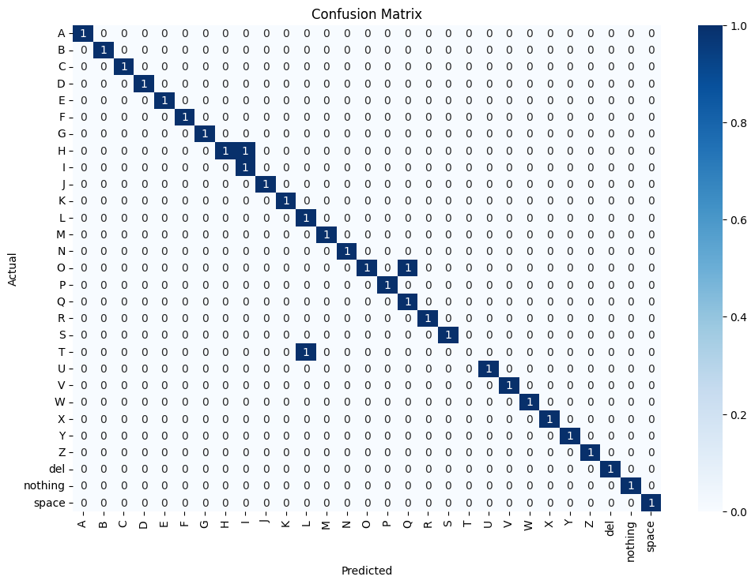
FIGURE 17: CONFUSION MATRIX
For Digits Dataset (0-9), following are the results or outcomes:
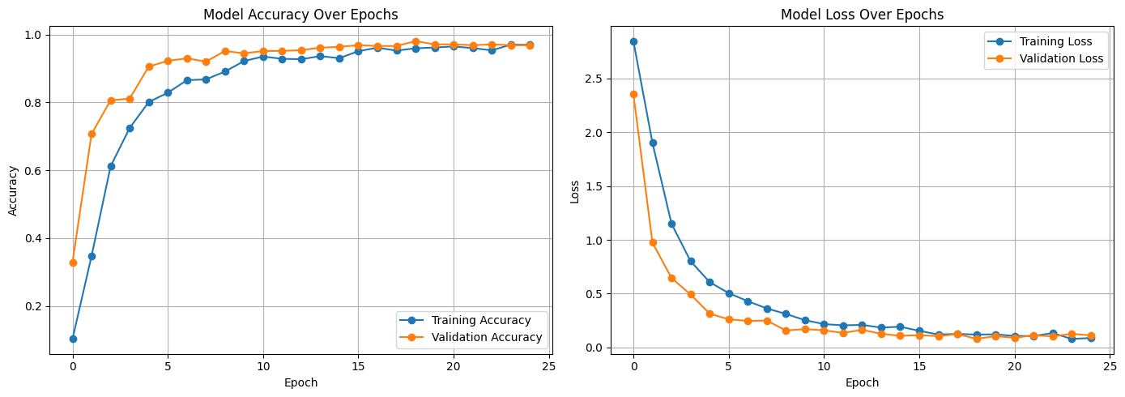
11.3.3: SEQUENTIAL MODEL:
FIG 18: MODEL ACCURACY & MODEL LOSS (25 EPOCHS)

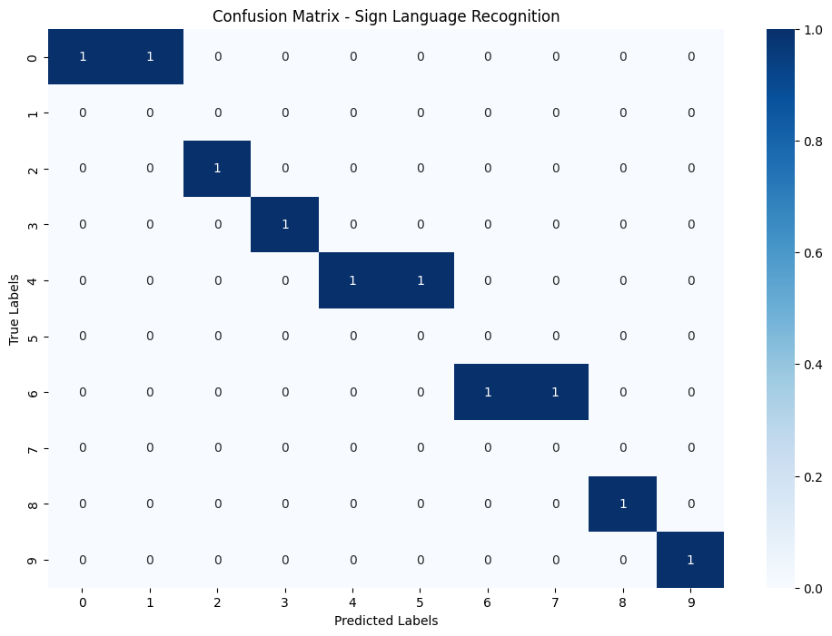
FIG 19: CONFUSION MATRIX
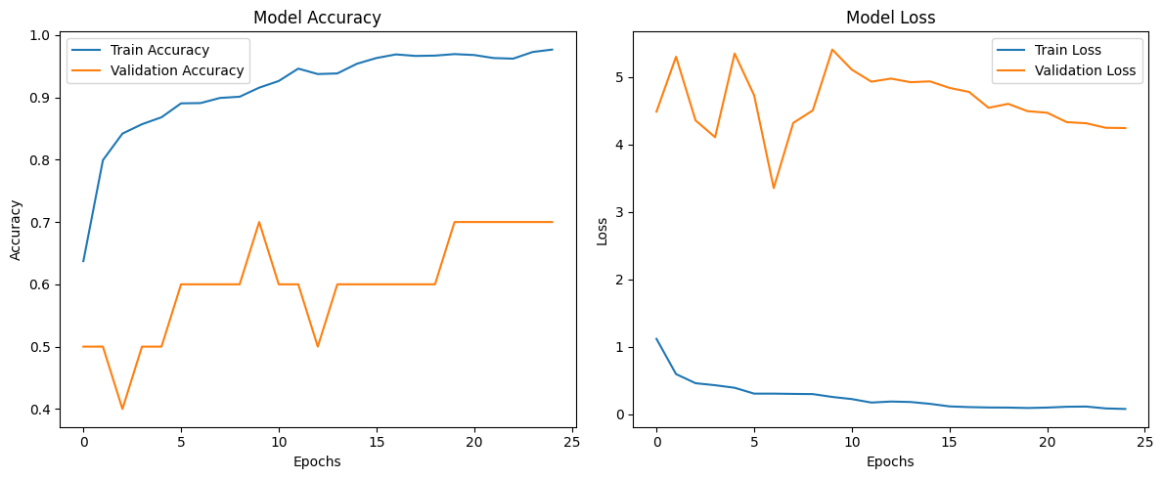
11.3.4: MOBILENETV2 MODEL:
FIG 20: MODEL ACCURACY & MODEL LOSS (25 EPOCHS)

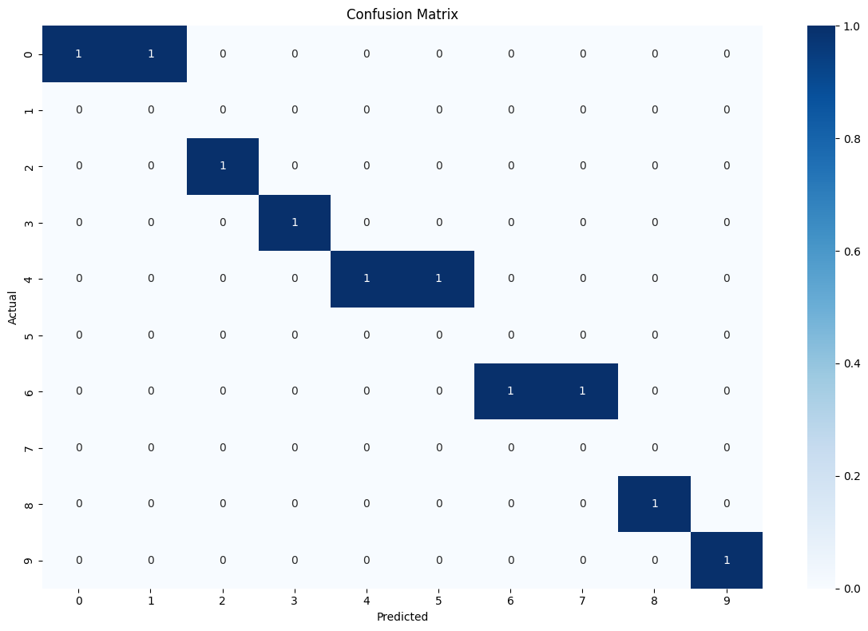
FIG 21: CONFUSION MATRIX (MOBILENETV2)
Upon training and observation of the loss and accuracy, the Sequential Model is performing better than MobileNetV2 Model. Hence, the Sequential Model will be carried forward with the development with also other alternatives of the MobilenetV2 Model.

12.CONCLUSION
In essence, the Hanzify project represents a significant step toward enhancing inclusivity, accessibility, and social integration through innovative technology. As a sign language translation app, it addresses critical communication barriers faced by the deaf and hard-of-hearing communities while promoting a more equitable society. Below are the key takeaways and achievements from this project:
- Bridging the communication gap
  - Hanzify successfully facilitates real-time translation between sign language and spoken or written text, enabling seamless communication between sign language users and non-users.
  - The app supports multiple sign languages, catering to a global audience and fostering universal inclusivity.
- Technological Innovation
  - By leveraging advanced technologies such as machine learning, gesture recognition, and natural language processing, Hanzify achieves high levels of accuracy and contextual relevance in translations.
  - The app’s ability to function on standard devices ensures accessibility without requiring specialized hardware.
- Practical Impact Across Domains
  - Hanzify empowers users in critical sectors such as education, healthcare, and workplaces, allowing for greater participation and opportunities.
  - It provides an affordable, scalable solution that can be widely adopted by individuals, organizations, and public services.
- Impactful Contribution to Society
  - Through Hanzify, the project demonstrates how technology can break down barriers, create opportunities, and empower marginalized communities.
  - It stands as a testament to the power of innovation in addressing real-world challenges.
- Scalability and future potential
  - The modular and future-proof design of Hanzify allows for continuous updates, including the integration of additional sign languages, enhanced features, and broader applications.
At last, the completion of Hanzify is not just the realization of a technical achievement but a meaningful contribution toward building an inclusive society. This project underscores the importance of combining technology with empathy to create solutions that truly matter. As it evolves, Hanzify has the potential to inspire broader adoption of inclusive practices and technologies, transforming lives and fostering equality for generations to come.

REFERENCES
- Introduction to Software Engineering by Professor Rajib Mall.
- Neural Networks and Learning Machines by Simon Haykin
- Fundamentals of Machine Learning by Dr. S. Uma
- Howard, A. G., et al. (2018). "MobileNetV2: Inverted Residuals and Linear Bottlenecks." arXiv preprint arXiv:1801.04381.
- ASL Dataset: https://www.kaggle.com/datasets/grassknoted/asl-alphabet
- Digits Dataset:
https://github.com/ardamavi/Sign-Language-Digits-Dataset/tree/master/Dataset

INITIAL COMMENTS & UPDATES
- Reframed the objectives as suggested by the evaluator: Objective number 2a and 2b has been updated.
- Gantt Chart has been updated and modified: Figure No. is labelled & Integration & Testing is extended.

